**SCIENTIFIC DATA VISUALIZATION**

Presentation Link: <https://prezi.com/view/ZV0l2LZi9mnEb1aDhTiW/>

### **PART I: Multivariate Data Visualization - Graphs**

### A dataset on student relationships is created and the below multivariate data visualization is deployed to represent the data with all its properties by using the visual cues like size, colour, thickness, length, etc. It includes the below listed attributes:

* Students
* Others (Names of the other related people)
* Relationship (Relationship of student with others)
* Strength (Represents the strength of the relationship)
* Length (Represents the number of years since they know each other)

One other field called Custom is created which is a conditional column based on the length attribute. A dark-to-light colour scale is assigned for the custom column to display the length of the relationship in the visual. The longest relationship is represented by dark colour and the shortest one with the light colour. Among these variables, relationship, strength, length and custom are the dependent variables and Students and Others are the independent variables.

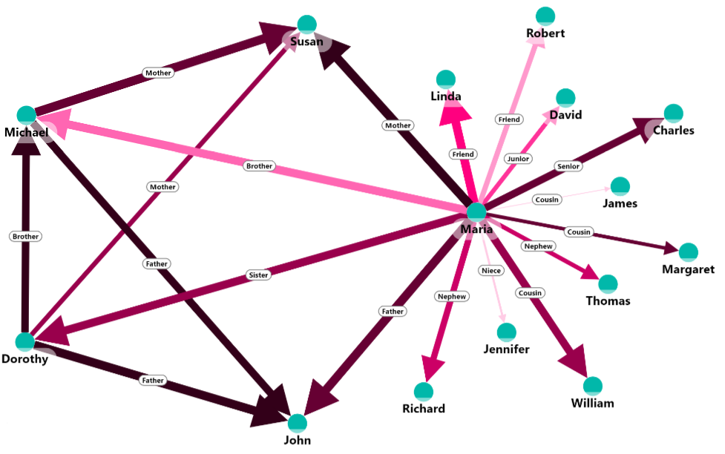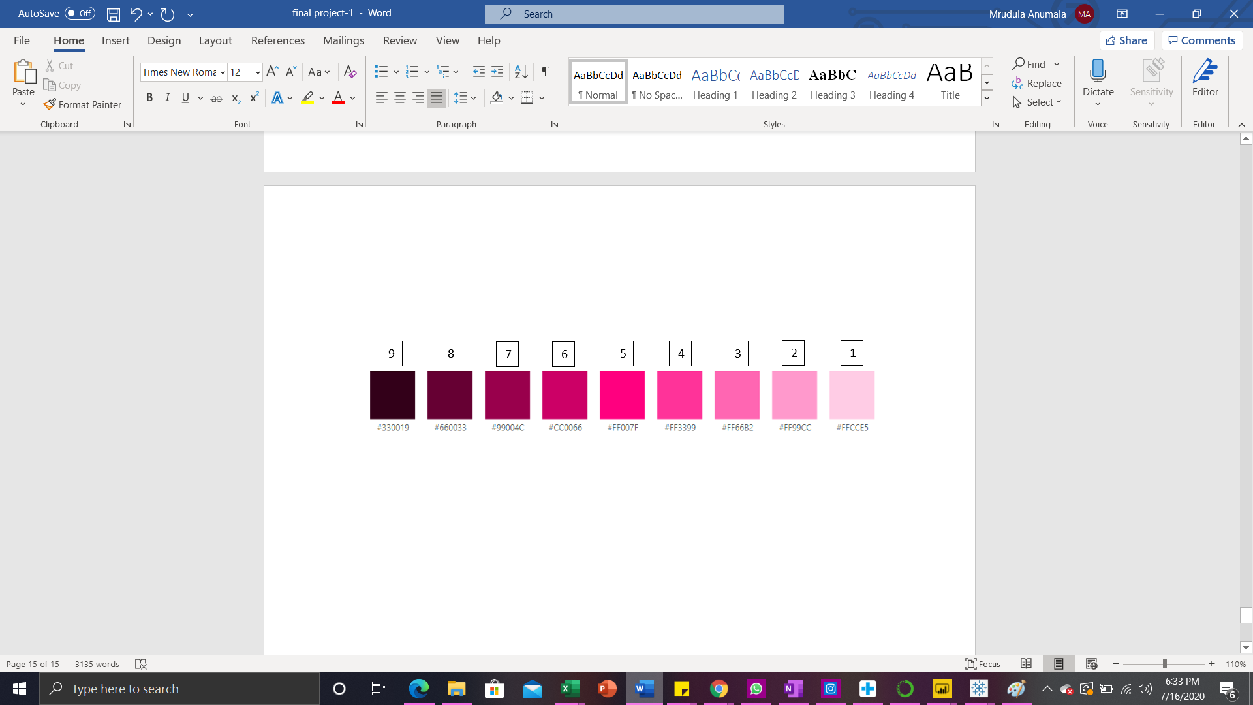

This is a custom visual called advanced graph visual from Zoom charts in Power BI with some advanced customization capabilities which is the first true graph structured data supporting visual. It brings a completely new way to explore the data and to dig in, to search for the connections, relations and insights within them. We can even identify outliers and discover patterns. To best emphasize the structure of the network, we can rearrange/reposition the nodes.

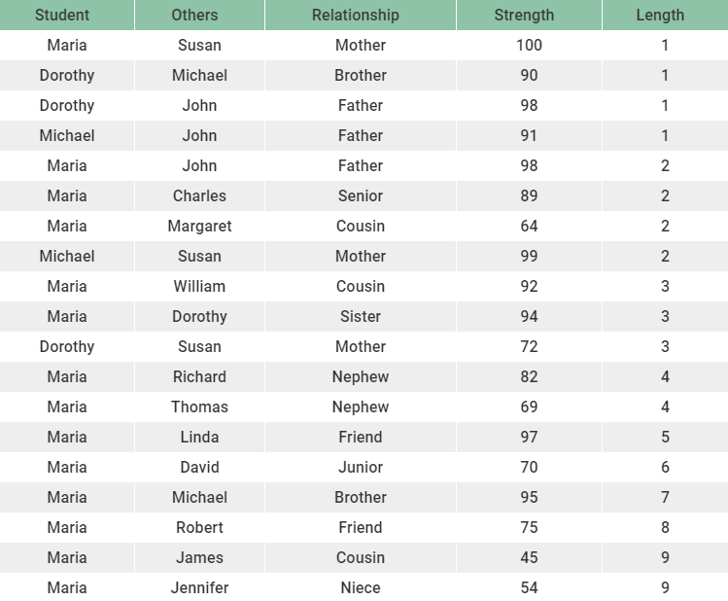

Students and Others attribute values are represented by green nodes. Relationship is represented as a label on the link. Strength of the relationship is represented by the width of the link. And finally to represent the length of the relationship, the created conditional column called custom is used on the links. Legend below the visualization shows the detailed variation on how the length is represented by the color.

From the visual we can clearly interpret that James is the cousin of Maria whose strength of relationship with Maria is the lowest one (45) among all because the width of the link is too small, and even the length of their relationship is very short because the link is assigned with a very light pink colour. Jennifer who is the niece of Maria also has the similar properties as James do, but with a bit more strength in the relationship.

The link between Maria and Susan who is the mother of Maria is the widest one among all others which represents the highest strength of relationships, and the darkest color of their link represents that they both are related since many years.

### **PART II: Exploring a Large Dataset with Tableau**

Below I have done the Exploratory Data Analysis on a crime dataset from the federal department. It is a huge dataset with nearly 6 million records. There are around 22 attributes and the analysis is done on the important attributes which are essential for deriving valuable insights. Case number, Primary type, FBI code, and the Year attributes are the ones that I have majorly focused on. Case Number is actually classified as a dimension in tableau, but converted to a measure for better EDA.

* FBI Codes => Federal Bureau of Investigation will classify and provide code for each sort of crime. Some examples of such crimes can be violent, non-violent, offensive, less-offensive, and so on. There are 26 FBI codes in the dataset.
* Primary Type => This is the primary reason for the crime. They can be classified as Assault, Robbery, Battery, Burglary, Kidnapping, Domestic Violence, and many more. There are a total of 35 primary types in the dataset given.
* Total number of criminal cases for each of the FBI Code are visualized below.

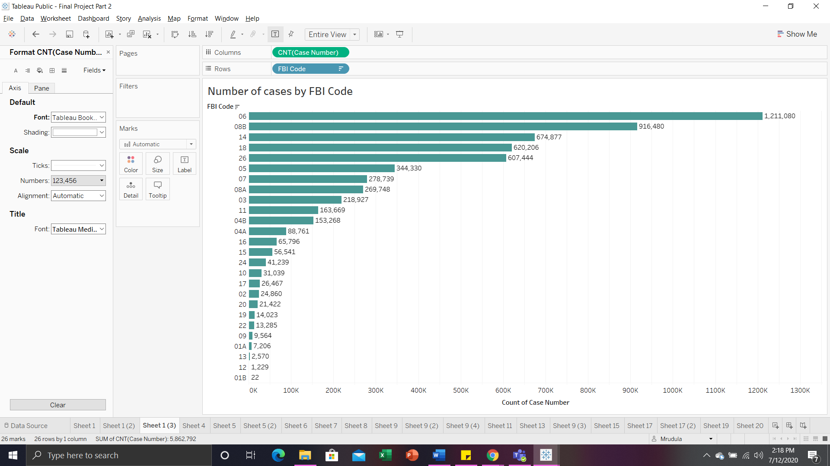

In a total of 5862792 number of cases, among the 26 distinct FBI codes, the FBI Code ‘06’ accounts for the highest number of criminal cases of 1211080, and the FBI Code ‘08B’ accounts for the second highest number of criminal cases of 91640. FBI Code ‘01B’ accounts for the smallest number of criminal cases of 22 during the whole period of 2001 - 2015, and this is the only FBI code with a total number of cases less than 1000 and 100 as well.

* Total number of criminal cases for each of the primary types of crime are visualized below. The primary type ‘THEFT’ accounts for the highest total number of cases of 1211078 and the primary type ‘BATTERY’ comes next with the second highest total number of cases of 1069724. ‘Domestic Violence’ primary type has only 1 case in total during the whole period.

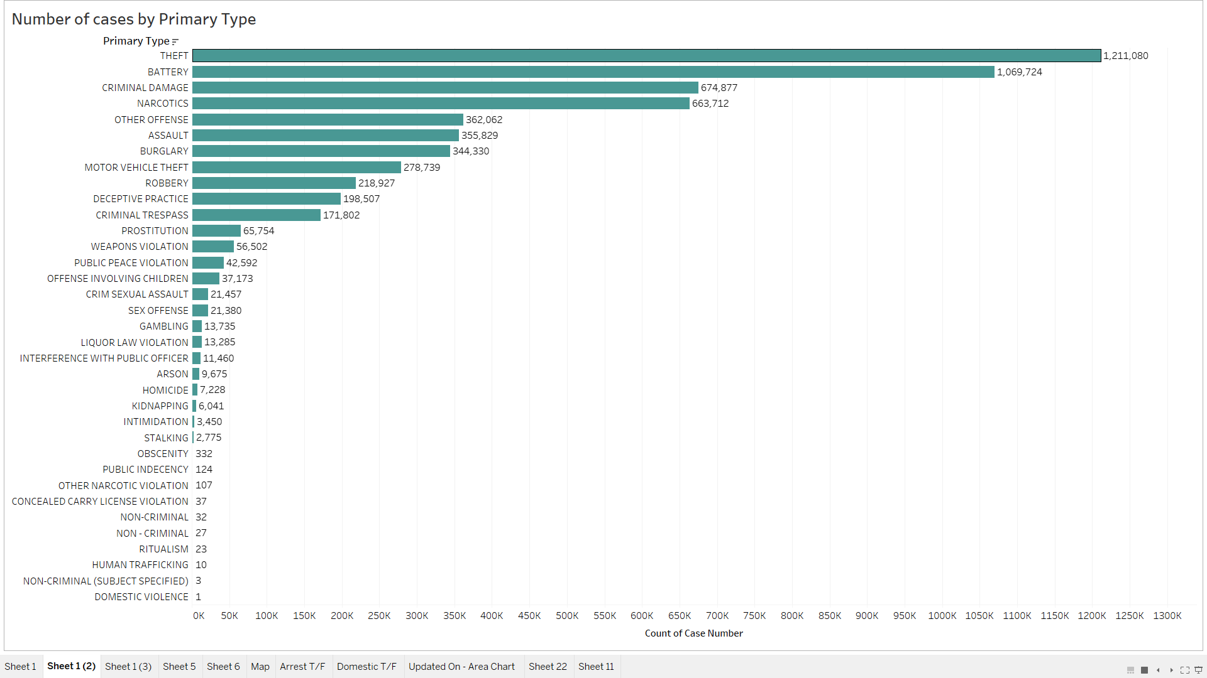

* The data is collected for the period 2001 - 2015 and the total number of criminal cases each year during the period is visualised. We can see the trend of committing a crime in the USA during this period.

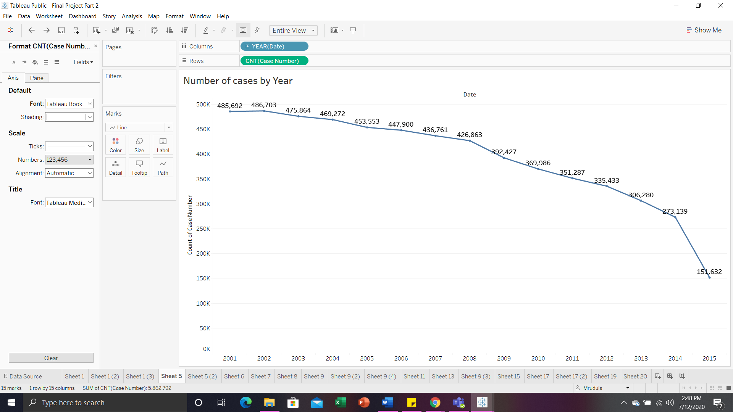

On the whole, the total number of criminal cases committed during the period 2001 - 2015 have decreased gradually. And there is an intense drop in the number of cases from the year 2014 with 273139 to the year 2015 with 151632. Only in the year 2002 there was a slight increase of 1011 in the number of cases compared to the previous year 2001.

* The Highlight table shown below contains the total number of criminal cases for Primary types of crime and FBI codes. FBI Code ‘06’ with a primary type of crime ‘THEFT’ accounts for the highest number of cases (1211078) during the whole period. The next highest one is the FBI Code ‘08B’, but under that, only the ‘BATTERY’ primary type of crime accounts for the majority of cases (916476). ‘RITUALISM’ and ‘DOMESTIC VIOLENCE’ primary types have only 3 and 1 number of cases respectively. Along with these two primary types of crimes, ‘NON-CRIMINAL (SUBJECT SPECIFIED)’ with FBI code ‘26’ and ‘NON-CRIMINAL’ with FBI code ‘15’ have the lowest number of cases of 3 and 2 respectively.

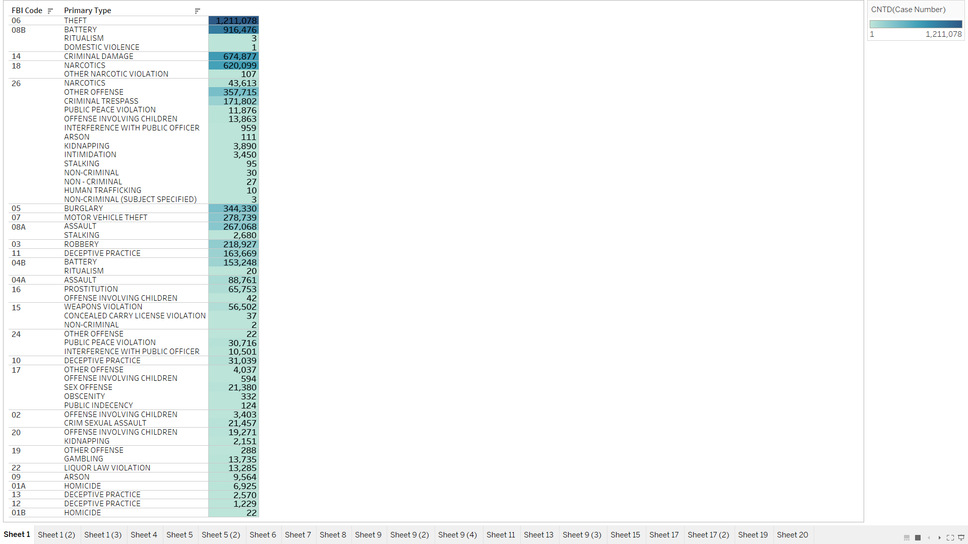

* In the Treemap visualization shown below, each location description is assigned a rectangular area of size based on the total number of criminal cases it accounts for. We can also see the total number of cases and the percent of total number of cases for each of the location description within the rectangular area. The dark-to-light color scale is also used for representing the number of cases. ‘STREET’ location description accounts for the majority of the total number of cases of 1573782 which is 26.84% of total. The next highest one is the ‘RESIDENCE’ location description with a total number of cases of 991882 which is 16.92% of total. We cannot see the details of the location description with the lowest number of cases, but all the required details are assigned to the tooltip so that we can get the respective information when we hover on it.

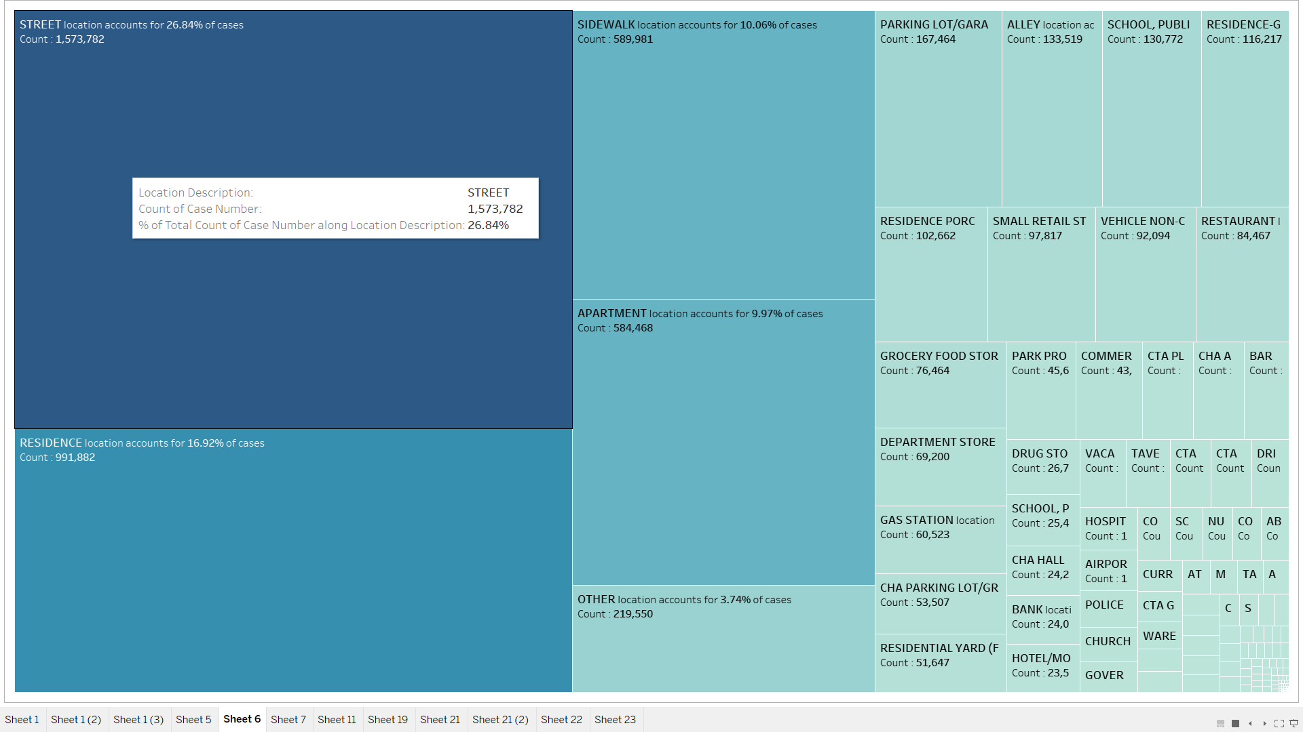

* The area chart shown below is just a quick and small insight on the number of cases updated each year on whole. Clearly we can see that most of the criminal cases are updated in the year 2006 and then in 2014.

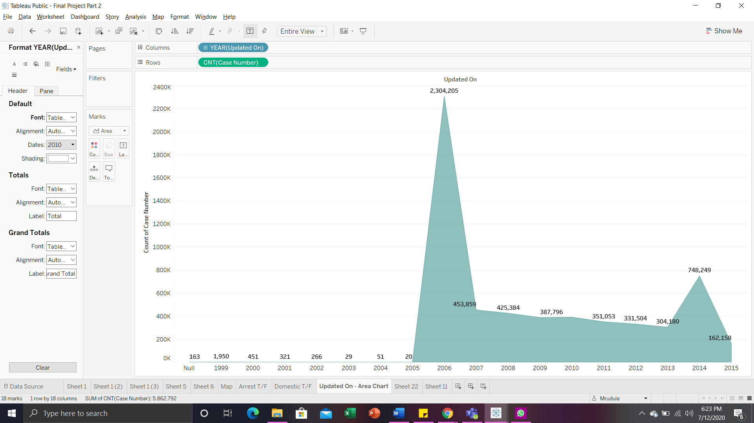

* Below bar charts show the number of cases by the boolean variables Arrest and Domestic. Criminals of 4172847 of cases are not arrested and criminals of 1689945 are arrested. 5118581 of the criminal cases are not domestic and 744211 of the criminal cases are domestic.

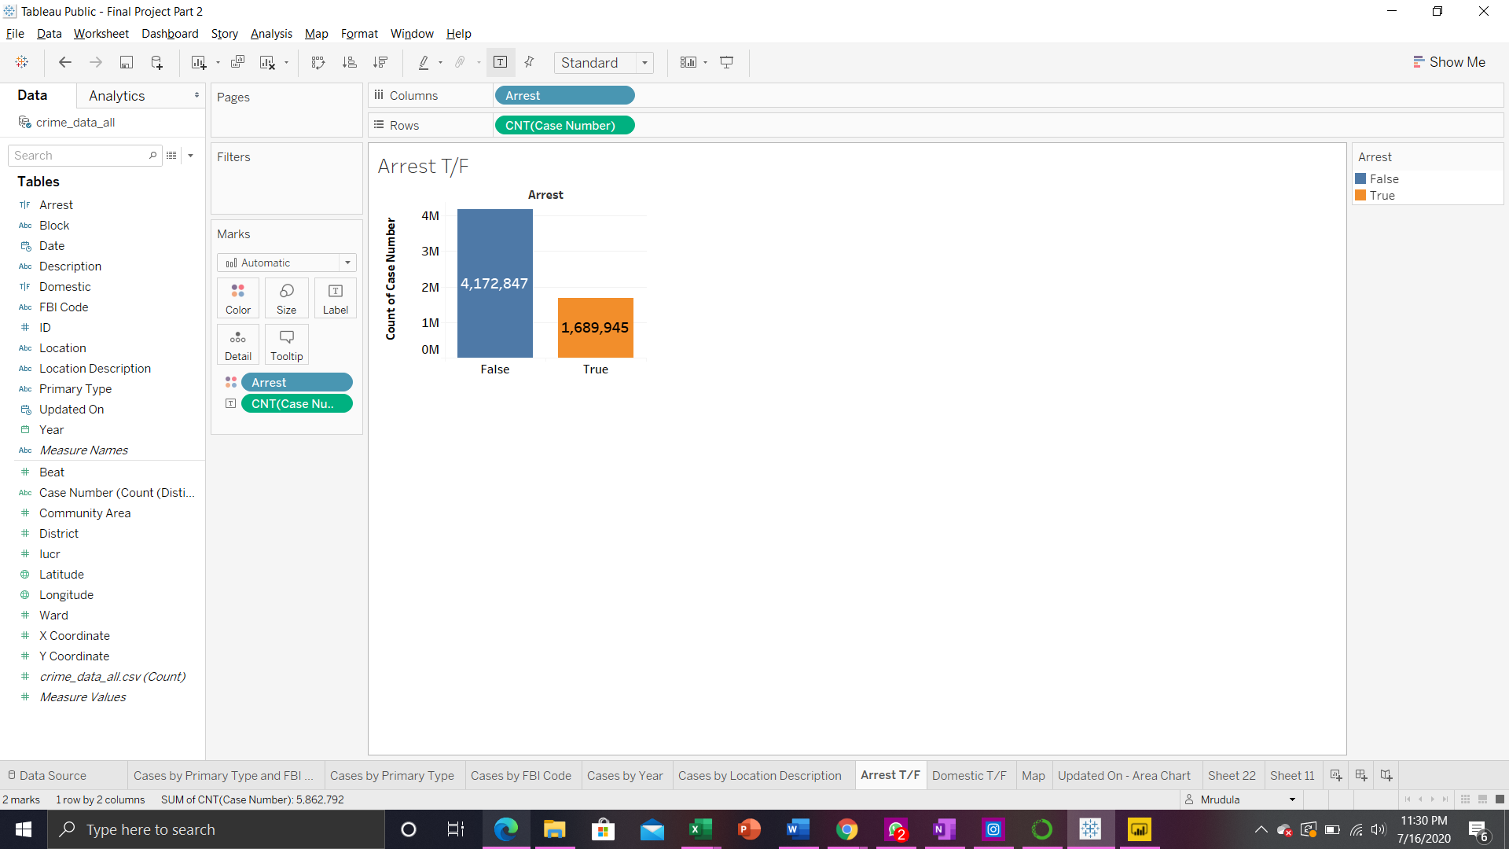 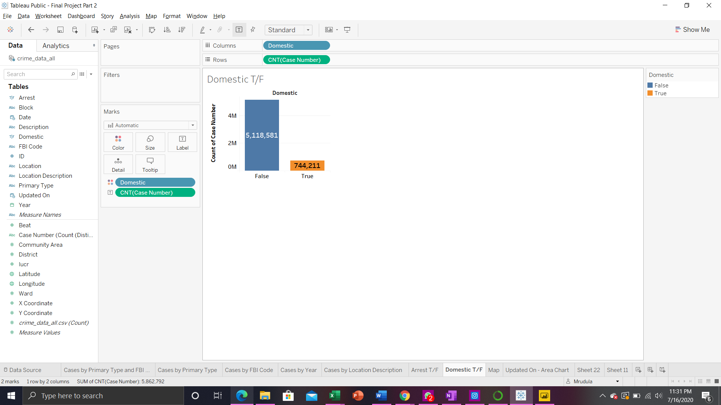

* Ward attribute is recognized as a measure by default in tableau, but it is converted to dimension for better EDA and the below visualization shows the number of cases by Ward. There are 614904 cases which are not assigned with any ward in the data. Ward 28 is the one with the highest number of cases - 240003. And the ward 19 is the one with the lowest number of cases - 47076.

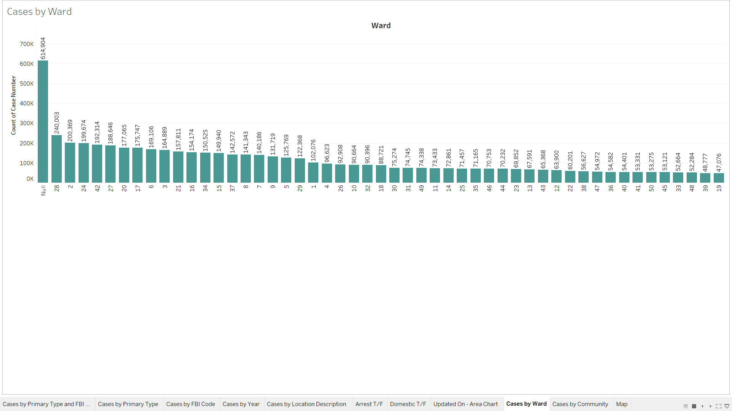

* Community Area attribute is recognized as a measure by default in tableau, but it is converted to dimension for better EDA and the below visualization shows the number of cases by Community Area. There are 615779 cases which are not assigned with any community area in the data. Community Area 25 is the one with the highest number of cases - 338029. And the Community Area 0 is the one with the lowest number of cases - 87.

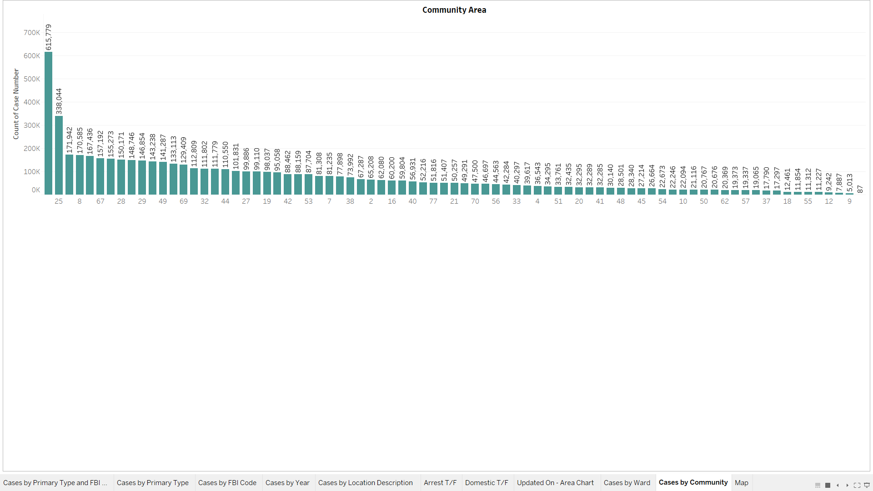

* On plotting the location coordinates in the view we can see that all the data on criminal cases is from Chicago. Density represents the number of cases in that particular location. Second visual represents the zoomed version of the map (first visual).

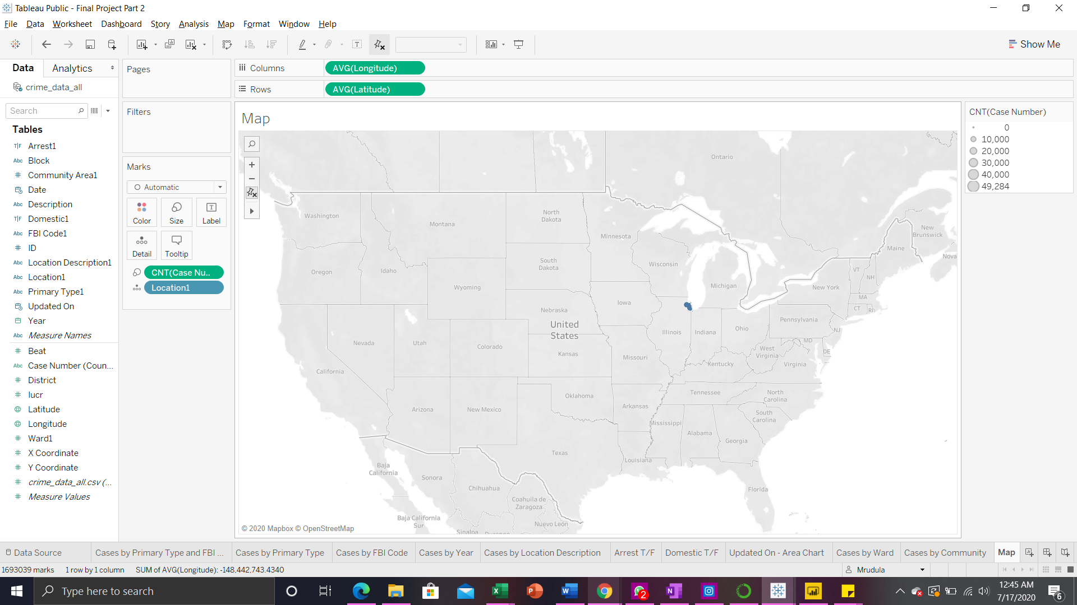

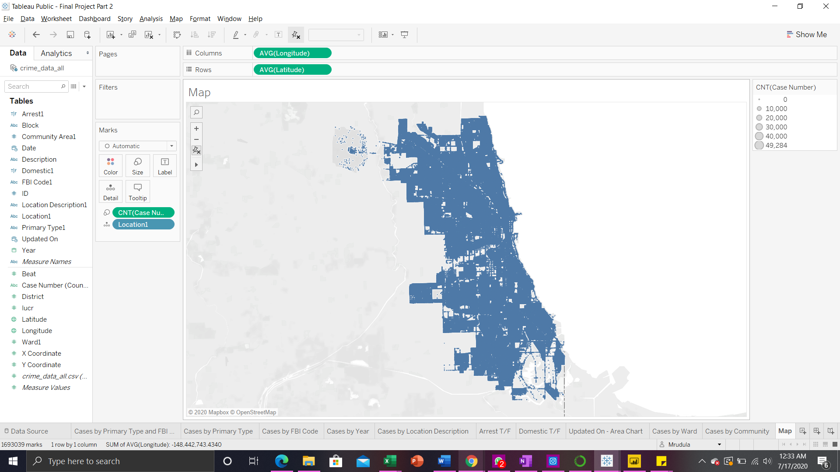

### **PART III: Data Visualization with Tableau**

Scatter plots are designed to show the relationship between two attributes. More specifically, to visualize the correlation between any two numeric attributes. Looking at the raw data, it is difficult to understand if there is any relationship between two attributes. But with a scatter plot, if there exists any patterns existing, it is much easier to see. To identify the outliers in the data, scatter plots are an excellent choice.

The aggregated pair that shows the sum of all sales and sum of all profit is split by using relevant dimensions mainly Category, and Region and adding them to the level of detail. The views are enriched by bringing more than one dimension onto the color or shape or size on the marks card so that the resulting view is much more insightful.

**Section 3.1**

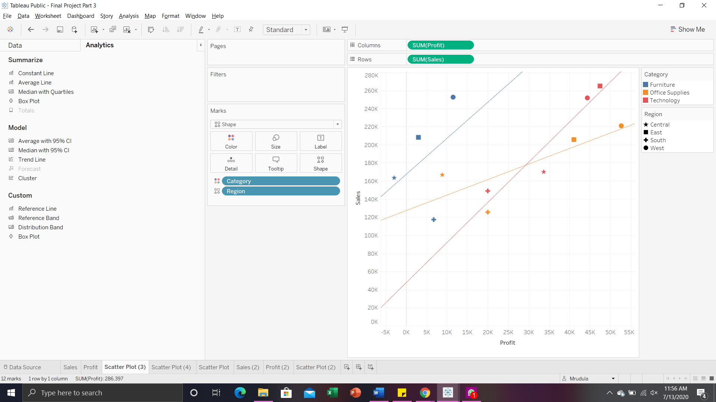

In the scatter plot shown above, we have Profit on the X-axis and Sales on the Y-axis. We increased the level of detail of the chart by adding Category to color and Region to shapes on the marks card. Their classification can be seen on their respective legends on the right side of the chart. Trend lines for each category are added to visualize the correlation between Profit and Sales. This visualization is aggregated and shows the information for the whole period. So, we can clearly see that a blue star which represents the Sales and Profit for the Furniture category in the Central region is having a negative profit of 2871 with a positive sales of 163797 which is quite similar to other marks. On the whole, the Furniture category is having comparatively low profit in all the regions. West and East regions are having high profits and sales as well. From the positively sloped trend lines we can depict that for all the categories, profit and sales are positively correlated but not necessarily by the same amount.

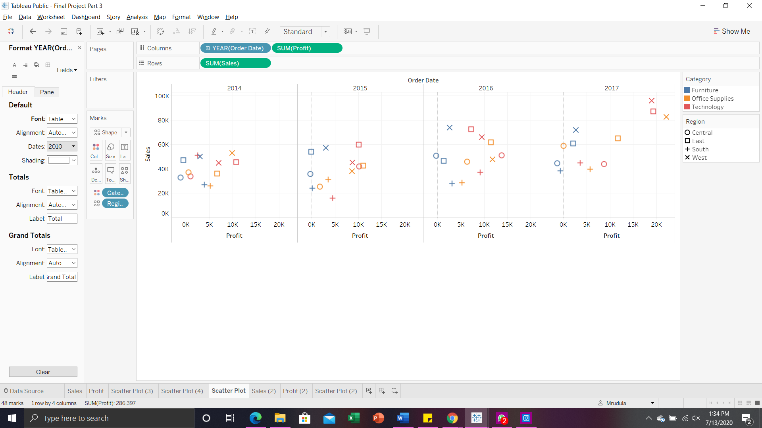

Dividing the first plot based on the order date, it is clearly evident that Furniture is having negative profits during the whole period. In all the years, East and West regions have higher profits than Central and South. Technology category in the West and East regions, and the Office Supplies category in the West region have higher sales and profit in the year 2017 than ever before. Technology and Office Supplies categories never had a negative profit during the whole period in any of the four regions. Furniture category in the central region had negative profits during the whole period of 2014-2017.

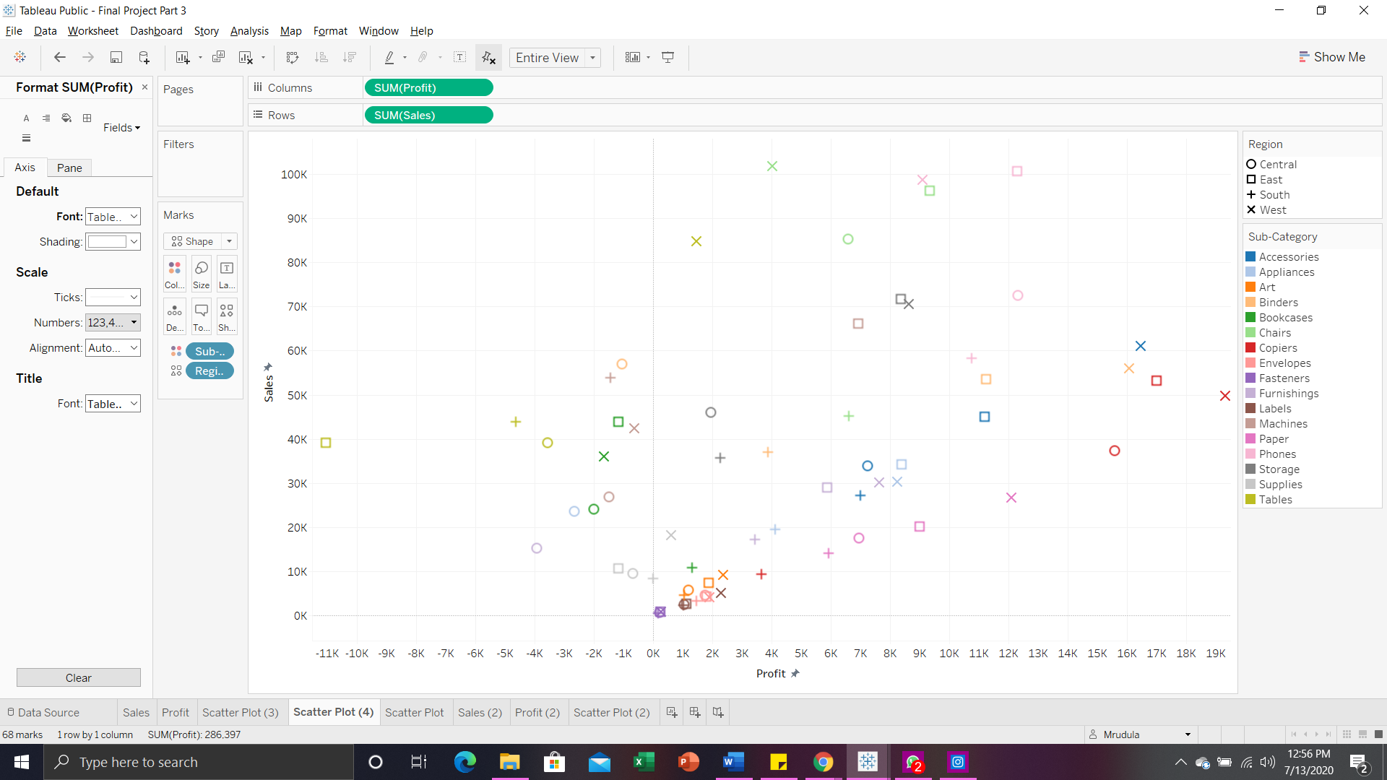

Above scatter plot for Sales and Profit with an increased level of detail by adding Region to shape and Sub-category to color. Fasteners sub-category have relatively low Profit and Sales less than 1000 in all the regions. Next is the labels sub-category having low profits ranging around 1K and sales ranging around 2K in all the four regions. Art and Envelopes sub-categories are also having low profit and sales. Tables sub-category in the East region is having a high negative profit of 11025 but has reasonably high sales of 39140. Tables, Machines and Bookcases are having negative profits in three regions. Copiers have high profits in all the regions except for the South region. Chairs have high sales in three regions but relatively average profit. Phones sub-category is having consistent profit and Binders sub-category is having consistent sales over all the four regions.

**Section 3.2**

In the below scatter plot with level of detail increased by adding Segment to color, Region to shape, and Category to size. Company should focus more on the consumer segment sales because it accounts for the majority of profit and sales. Next comes the Corporate segment, and then at last, the Home Office segment. Technology category in the East and West region is having high sales for the consumer segment of customers. Furniture category for the segments consumer and home office have negative profits of 3994 and 1199.

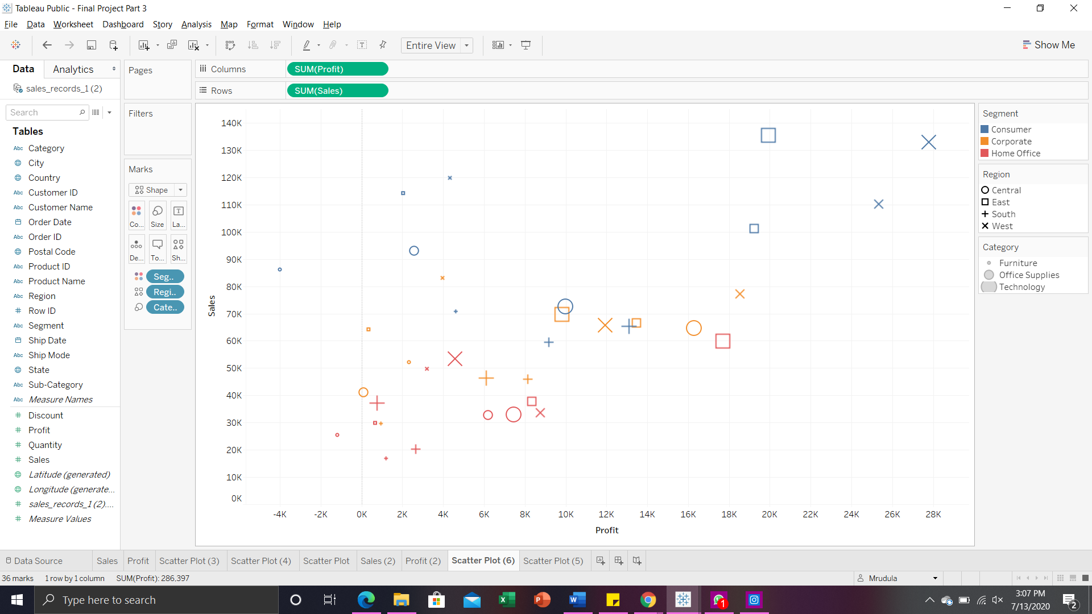

On adding Sub-category to detail, we get the below scatter plot where the segment is classified by color and the region is classified by shape. Consumer segment has negative profits for tables and bookcases sub-categories in most of the regions. Under the Office Supplies category, all the three segments have most of the sub-categories within the range of Sales from 0 to 4000 and Profit from 0 to 1000. The Central region has better profits for the Technology category. West is the only region that does not have any negative profits for any of the sub-categories under the Office Supplies category.

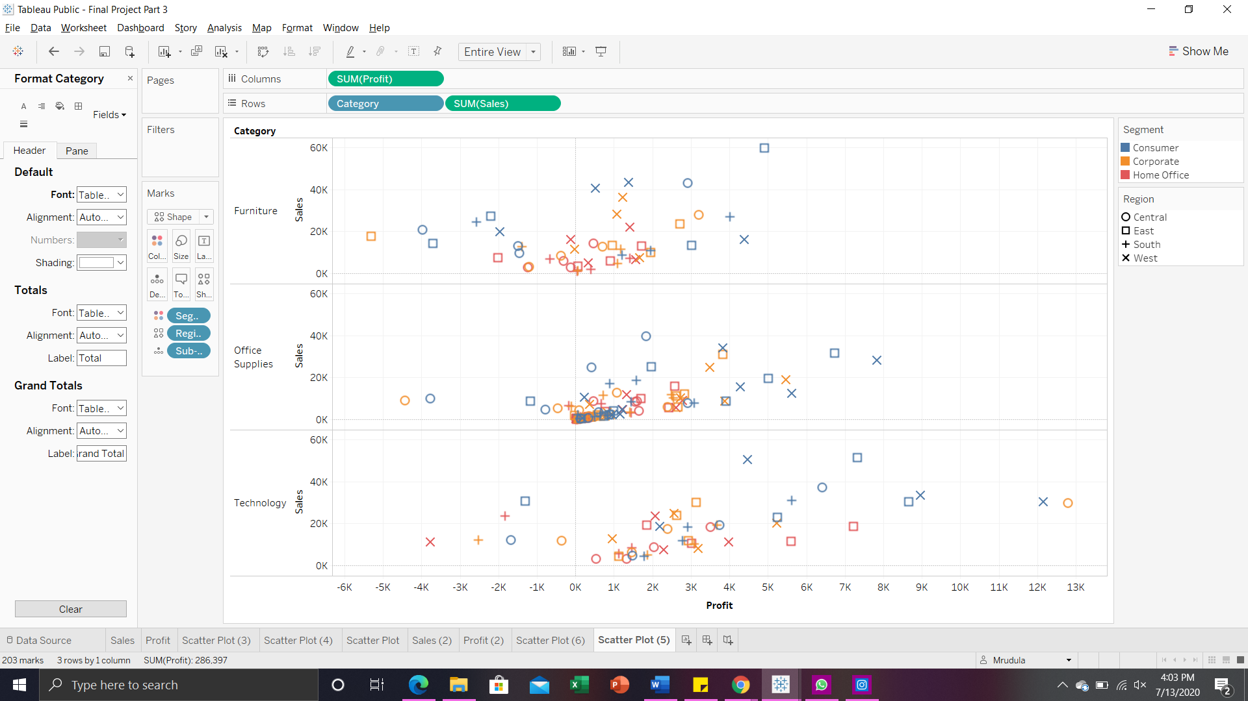

We have two quantifiable variables - Sales and Profit in our scenario, and scatterplots are all about relationships which we are trying to achieve in this scenario. It helps us in determining how closely Sales and Profit are related and we can depict if one has any impact on the other.

The advantage of using a scatter plot visualization for this scenario is that,

* We can show if there is any non-linear pattern within the data.
* We can determine the range i.e., minimum and maximum of data flow (Sales and Profits in this case).
* Insights can be visualized straightforwardly.
* We can even predict on how one attribute changes as the other does the same.

### 

### 

### 

### **PART IV: Data Visualization with Python Pandas and Matplotlib**

Pima_diabetes dataset consists of 8 predictor variables - Pregnancies(preg), Glucose(plas), BloodPressure(pres), SkinThickness(skin), Insulin(test), BMI(mass), DiabetesPedigreeFunction(pedi), Age and 1 target variable Class.

Variables descriptions:

1. preg: Number of times pregnant (preg)
2. plas: Plasma glucose concentration a 2 hours in an oral glucose tolerance test (plas)
3. pres: Diastolic blood pressure in mm Hg (pres)
4. skin: Triceps skin fold thickness in mm (skin)
5. test: 2-Hour serum insulin in mu U/ml (insu)
6. mass: Body mass index measured as weight in kg/(height in m)^2 (mass)
7. pedi: Diabetes pedigree function (pedi)
8. age: Age in years (age)
9. class: 0 or 1 (no or yes)(negative or positive)

I have imported the required packages numpy, pandas, matplotlib, seaborn for the data visualization. Dataset is placed in the same directory as that of the dataset and the field names are specified as listed above. Dataset is loaded into the pandas dataframe.

Each numeric variable of the dataset are plotted as univariate Visualizations:

1. Histograms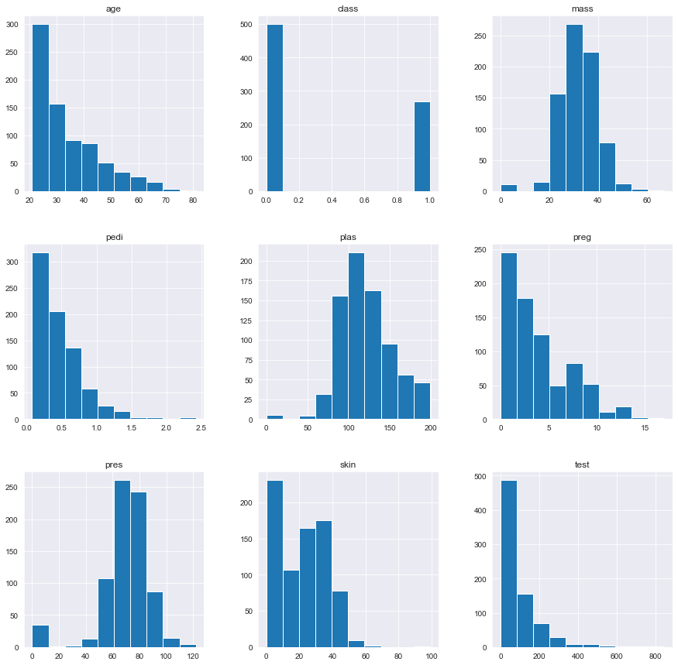

Attributes BMI, BloodPressure, Glucose are found to be normally distributed. BMI and BloodPressure nearly have Gaussian distribution. Age, DiabetesPedigreeFunction, Insulin, Pregnancies found to be exponentially distributed.

1. Density plots

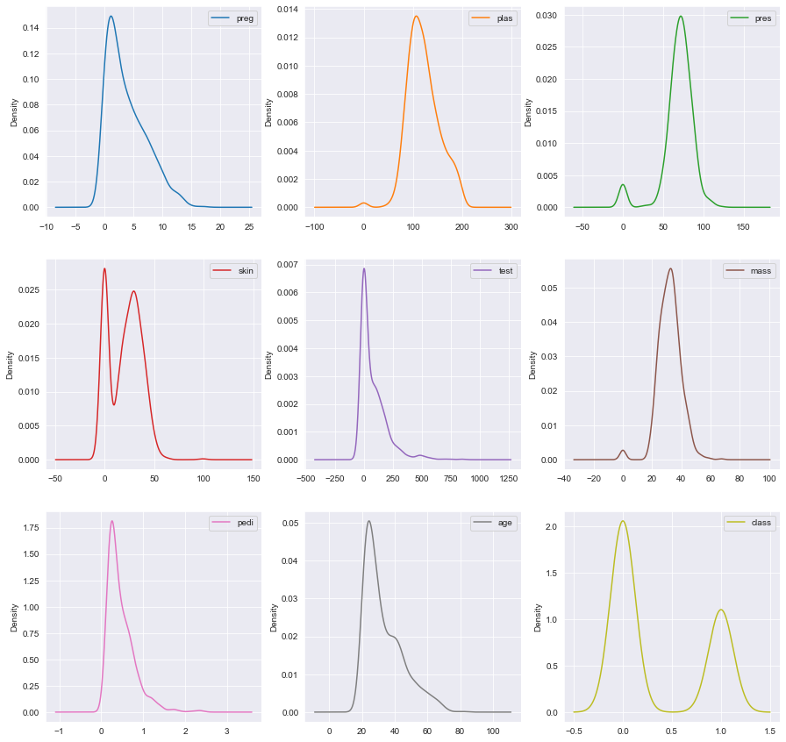

1. Boxplot

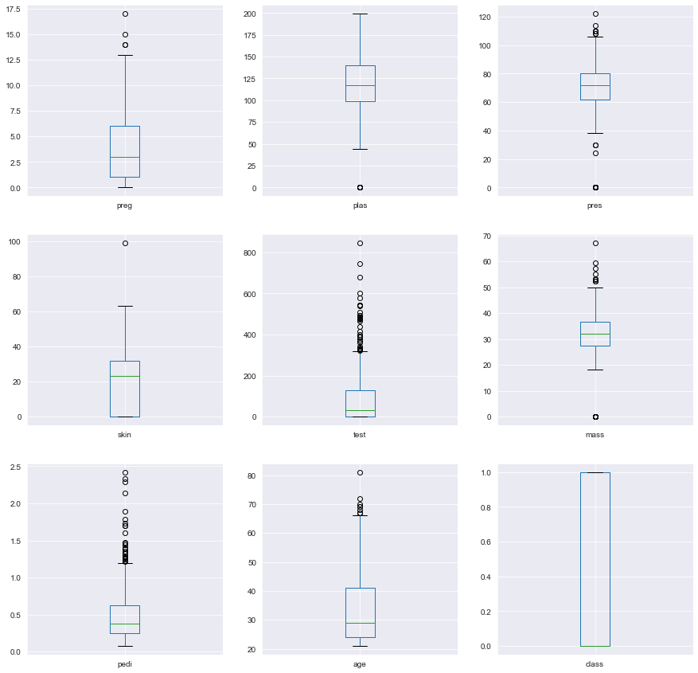

Spread of attributes is quite different. Attributes Age, Insulin appear to be quite skewed towards smaller values.

1. Line Chart

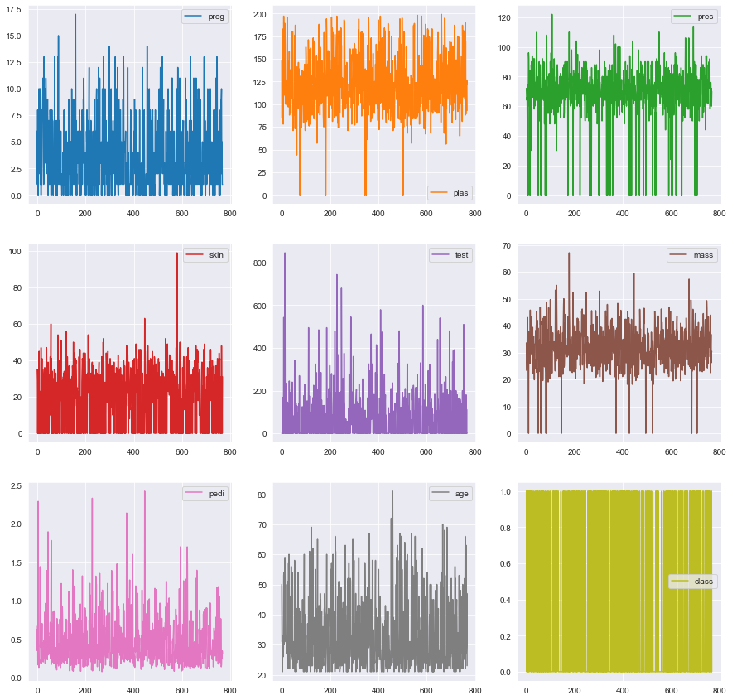

1. Area Chart

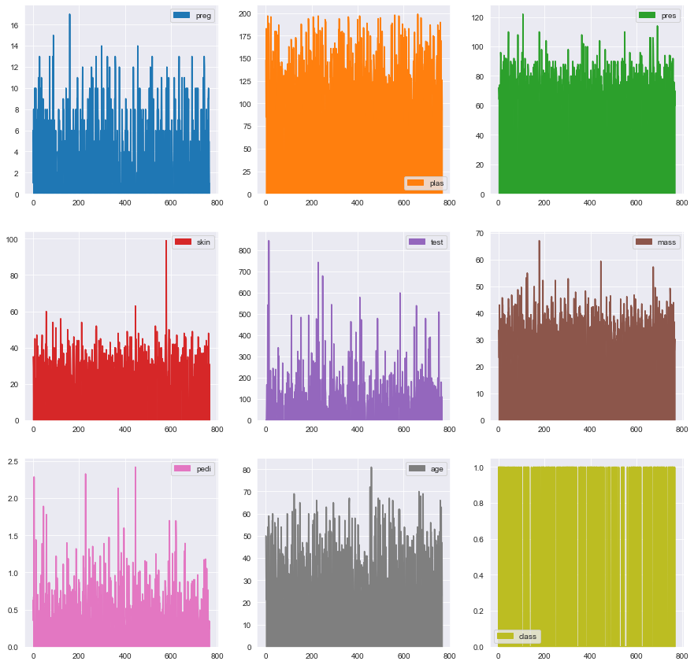

1. Distplot

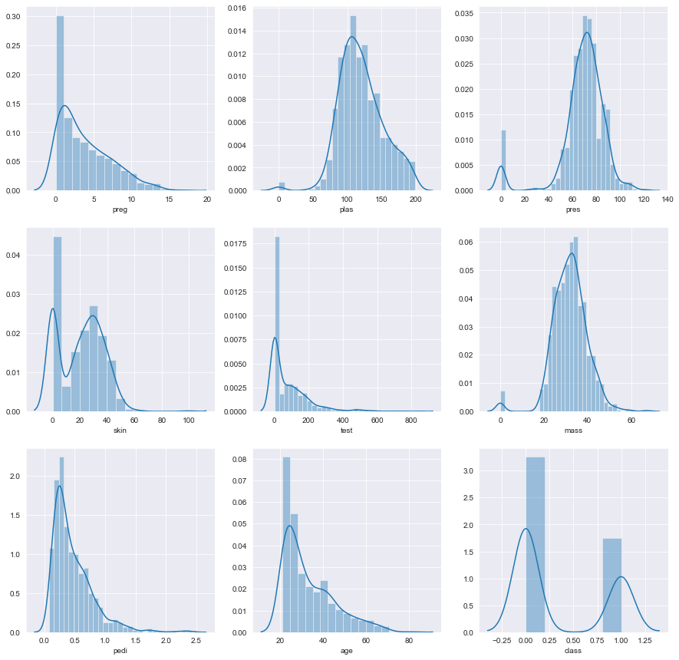

1. Countplot

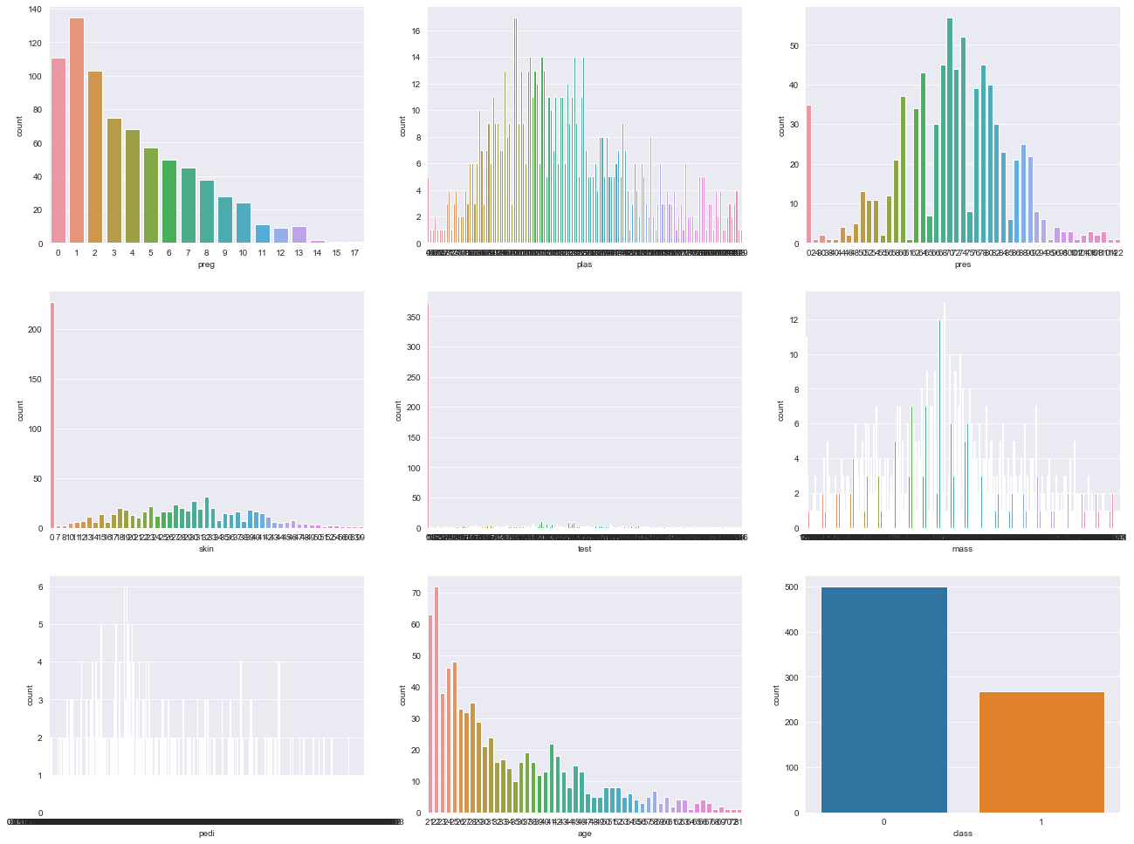

1. Violin Chart

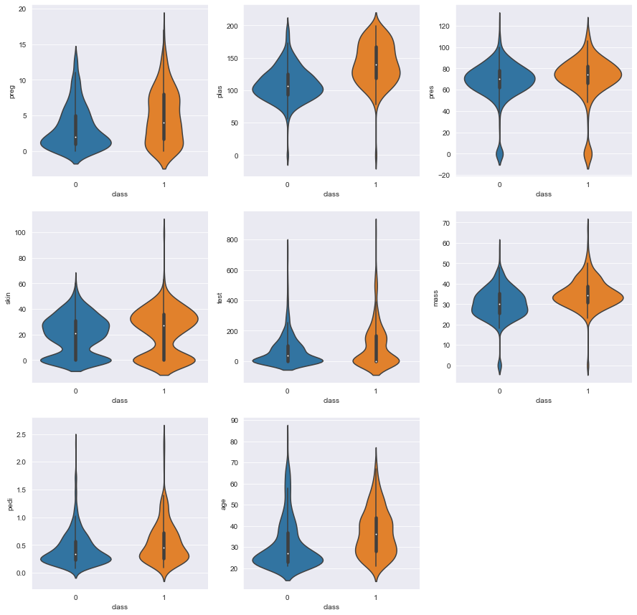

Visualizing the relationship between each pair of numeric variables - Multivariate data visualization:

1. Scatterplot

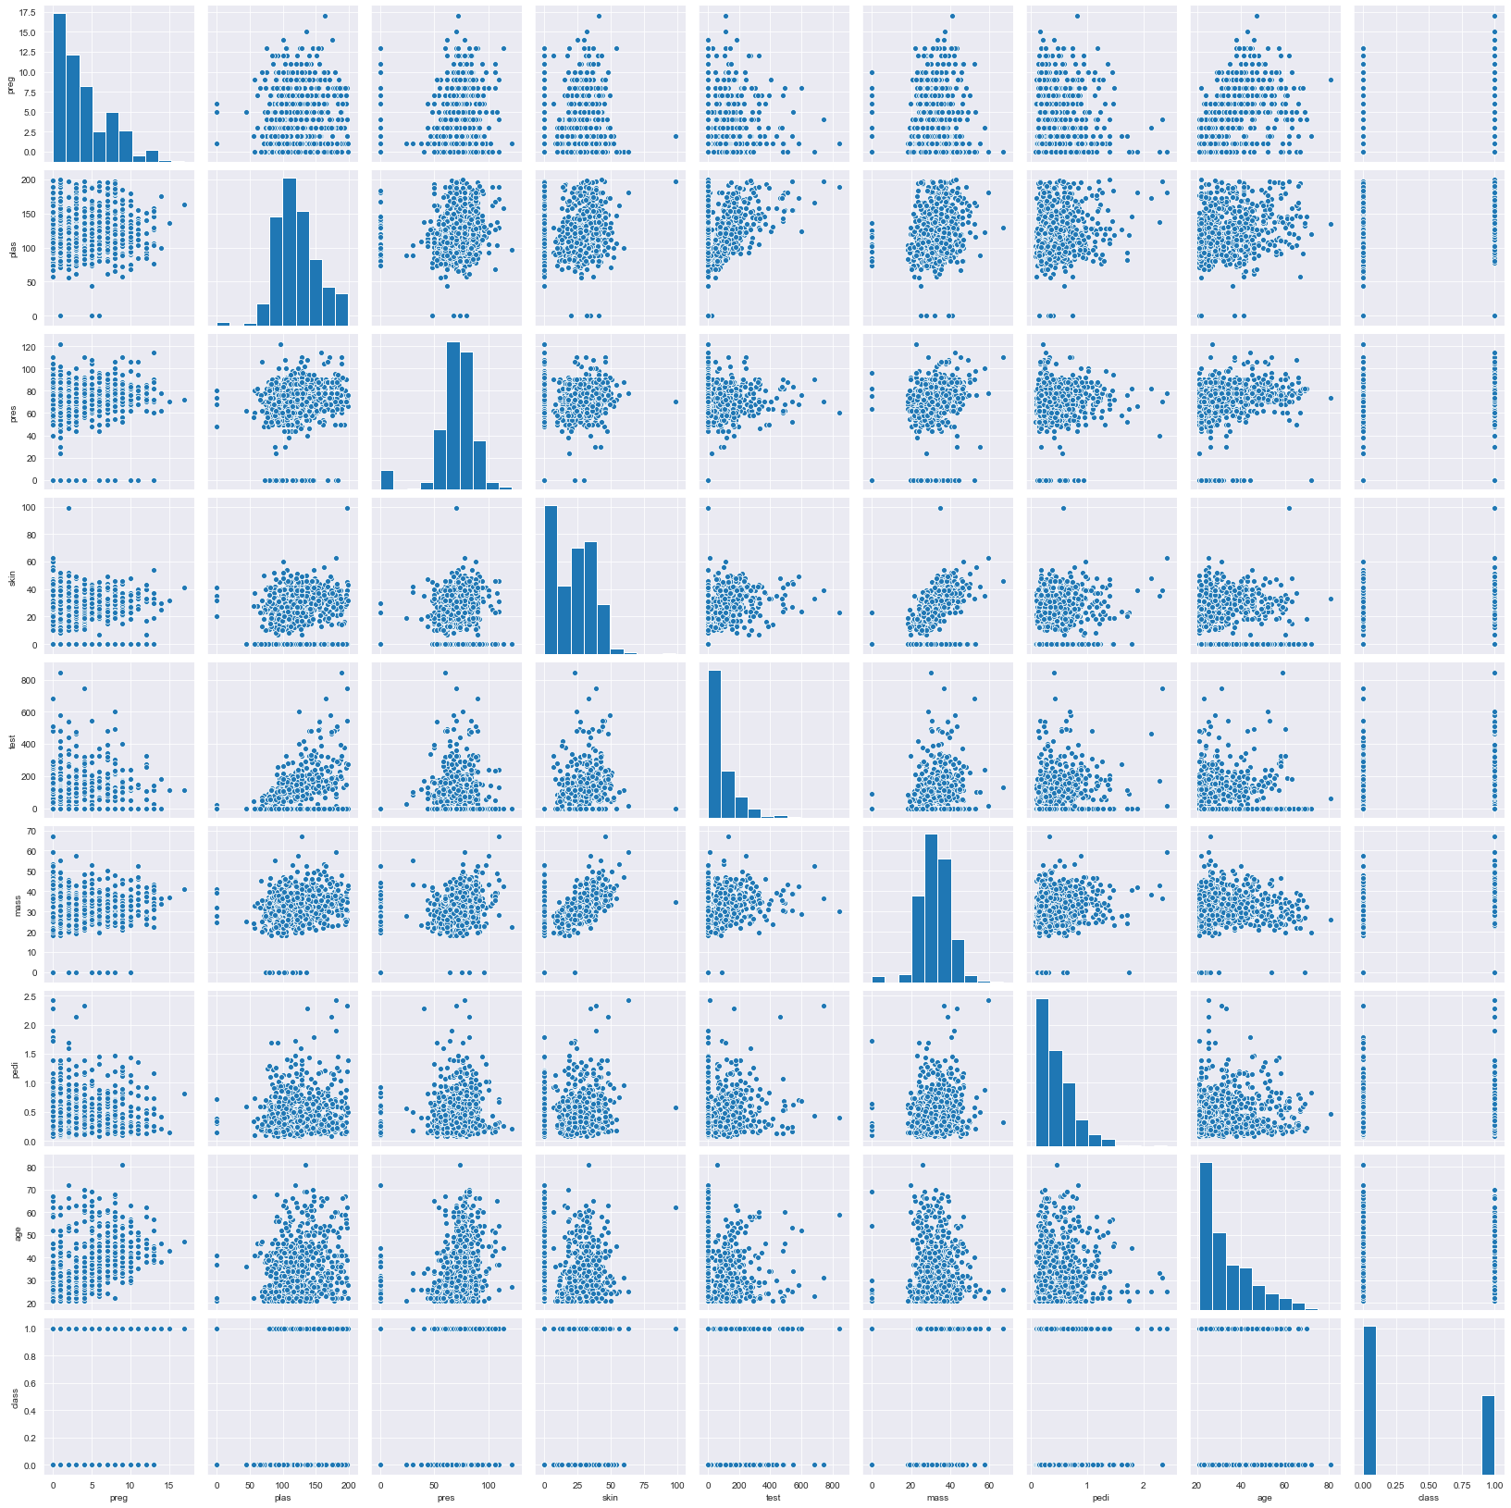

1. Correlation plot

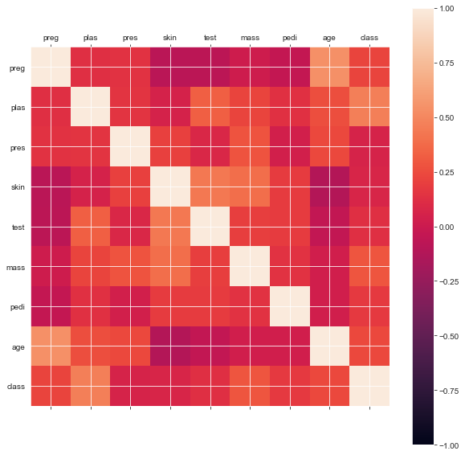

* Attributes BloodPressure, SkinThickness are not much related to outcome.

1. KDE plot

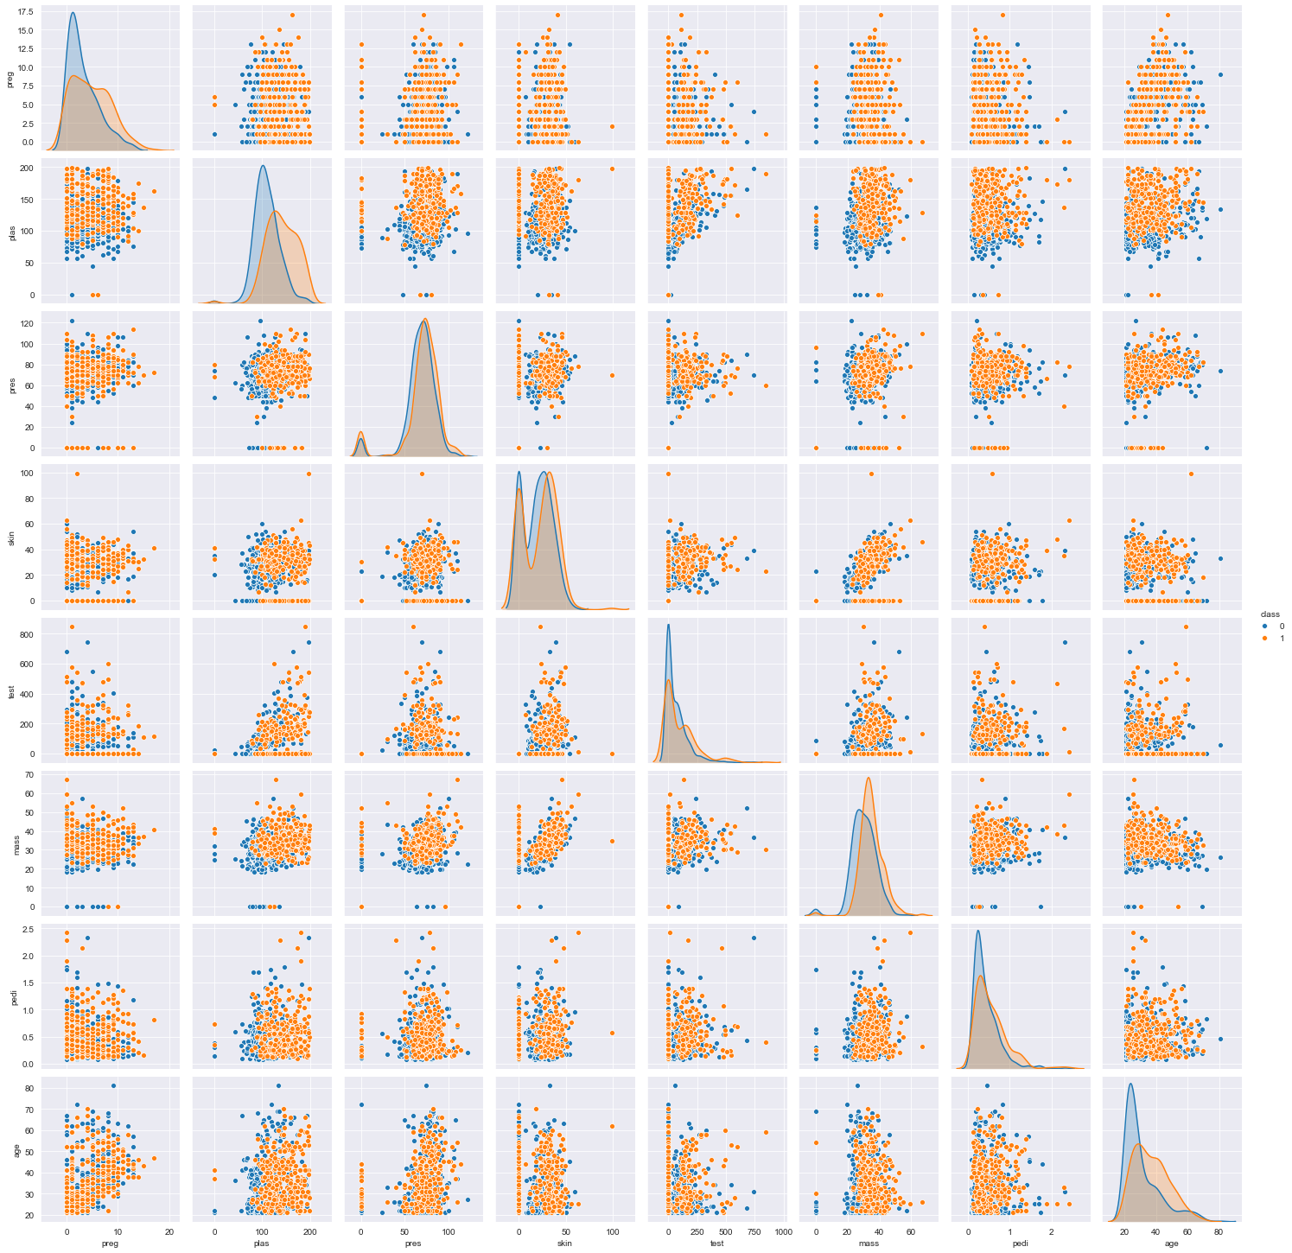

1. 2D Kernel Density Plot

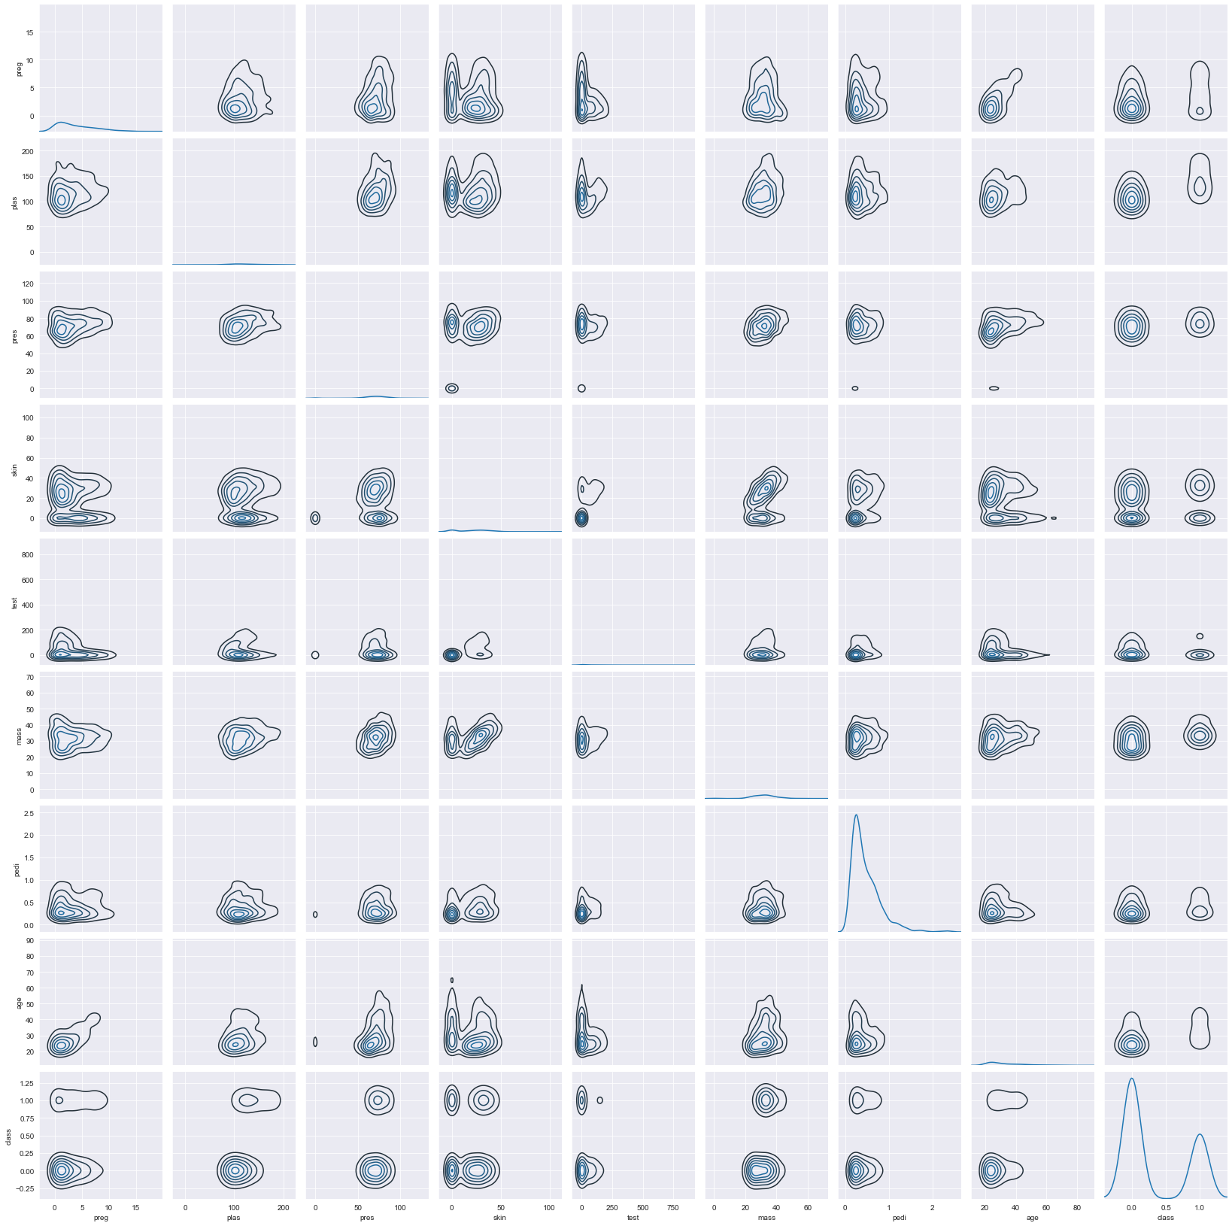

The SVM linear model is used for the prediction and observed an accuracy of 82.46% on the test set.

